What Is The Best Program To Edit Music Videos?

What is the best program to edit music videos for aspiring artists? You'll find countless video-editing programs both online and offline that promise to give you the creative freedom to create masterpieces worthy of the Academy Awards. It is important that you make your decision based on sound reasoning rather than emotion or personal preference.
When deciding which program to use, you must first examine your personal editing style. Do you have a knack for creative editing? Do you make good use of text and graphics in your videos? Or do you prefer to see something purely as a picture? This will help you determine which video editing software package you should choose.

What should you consider before choosing a program or software to edit music videos
- Many new video editing programs come bundled with pre-made templates for movie-quality effects and basic movie scoring. If this is the case, you can freely use these resources. However, if you want your editing to be truly individualized, you need to create your own movie theater complete with your own sounds and music tracks. That said, most professional editors offer an extensive library of sounds that you can freely download and use in your project. If the editor you are considering doesn't offer this, it may be a good idea to look elsewhere.
- You should also examine the features offered by the video-editing software. Are the features useful for what you want to accomplish? For example, if you plan on submitting your video to online review sites or online contests, does the editing software come with built-in SEO (search engine optimization) tools? Does it have automatic file resizing?
- The first thing you need to do is make sure you have great equipment. It is not necessary to rent a costly digital video camera when you just want to make an educational or training video. In fact, for many types of videos, you may be better off with a less expensive camera and using it only for the best moments. The same goes for those who intend to submit their work to viral marketing schemes or to use copyrighted materials without obtaining proper authorization.
- Another key consideration when considering what is the best program to edit music videos is to think about the user interface. What user interface (the controls and menus you are used to operating) does the editing software offer? Is it easy to navigate through the process? What are the primary controls and menus? Are the options for each tool and option listed clearly? Are the features age-appropriate?
- Another important thing to consider when looking for what is the best program to edit music videos is whether or not you will be able to find professional assistance in case you need it. Even with professional video editing software, some aspects of editing may not be possible without assistance. For example, in some cases, a small mistake can result in an entire video being redone or even removed from YouTube because of a mistake that the editor made. This is why it is especially important that you work closely with the software company to select the program that best meets your needs. After all, the company offering the editing service will be responsible for learning your computer software and ensuring that it will meet your editing needs.

Some software to edit music videos

Filmora Video Editor
Filmora video editor is the easiest video editing application that offers you to edit, personalize or customize your video with music, effect, filter, template etc. with the use of its excellent feature you can edit your video in easy and full feature mode. You can create your videos with music effects easily. You can customize your videos with text, title, template, transition, overlays etc.

InShot
InShot offers you to speed up, trim, filter effect, adjust audio, add background and use music filters to your videos. You can add your own music to the video through the application. You don’t have to invest a lot of time in editing videos with this software.

PowerDirector
It offers you easy and powerful features like- green screen editing, music effect, motion graphics, filter, audio editing, Multi-track editing and keyframe controls. This application has “background, templates, elements” options. PowerDirector app helps you to create high-quality videos and its motion-tracking feature helps you to focus on the specific side of your video. And the erase option lets you remove the clip in your video.

KineMaster
KineMaster offers you a multiple-layer editing option. You can use text, images, audio customization and music effects. It has multi-track editing and blending modes. You can create your video with high-resolution. Its trimming and splitting option helps you to make your video perfect.

What is the best program to edit music videos? These are questions that many people often ask themselves but knowing your own personal requirements will help you choose the right application. When you have determined what your editing needs are, it will be easier to find the appropriate application and learn how to use it effectively. Remember to always ask for examples of previous work, so that you can get a better idea of the type of editing that will be required.
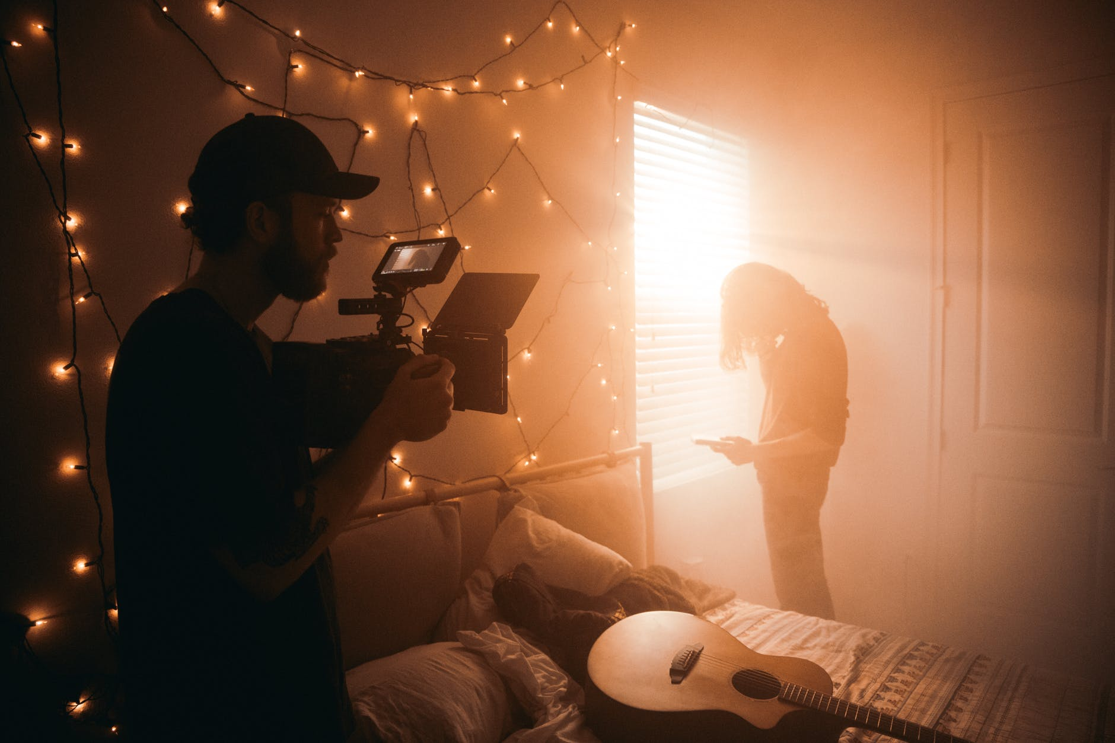

Project ID: | viddeditHD111
Title: | What is the best program to edit music videos?
Length: | 850
Guideline: | Guidelines for the writer:  ============  - Should be high quality and we don't want any type of mistake  - Language---English native  - it is not allowed that a single word repeats more than 15-20 times in the article.  - Insert 2 authority websites links in the post & one client link with the given anchor
Anchor Word | video-editing
Anchor Link | https://www.viddedit.com/

Samples or any other instruction
- https://www.iskysoft.com/video-editing/music-video-editing-software.html
- https://www.pcmag.com/picks/the-best-video-editing-software
- https://blog.hubspot.com/marketing/best-video-editing-apps

